

Requirement & Design Specification

**PC BUILD - GEAR WEBSITE (PBGW)**

**Version: 1.0**

– Hanoi, August 2022 –

# Record of Changes

| **Version** | **Date** | **A* M, D** | **In charge** | **Change Description** |
| --- | --- | --- | --- | --- |
| V1.0 | 15/2 | A | KienNTHE11 |  |
| V1.1 | 23/5 |  | Dattqhe186281 | Change Use Case Decription |
|  |  |  |  |  |
|  |  |  |  |  |
|  |  |  |  |  |
|  |  |  |  |  |
|  |  |  |  |  |
|  |  |  |  |  |
|  |  |  |  |  |
|  |  |  |  |  |
|  |  |  |  |  |
|  |  |  |  |  |

*A - Added M - Modified D - Deleted

Contents

Record of Changes 2

I. Overview 4

1. User Requirements 4

1.1 Actors 4

1.2 Use Cases 4

2. Overall Functionalities 5

2.1 Screens Flow 5

2.2 Screen Descriptions 5

2.3 Screen Authorization 5

2.4 Non-UI Functions 6

3. System High Level Design 6

3.1 Database Design 6

3.2 Code Packages 7

II. Requirement Specifications 8

1. <<Feature Name>> 8

1.1 <<UseCaseCode_UC Name>> 8

2. Common Functions 11

2.1 UC-2_Login System 11

3. Patron Feature 12

3.1 UC-5_Order a Meal 12

3.2 UC-6_Register for Payroll Deduction 13

III. Design Specifications 14

1. <<Feature Name>> 14

1.1 <<SubFeature Name>> 14

1.2 System Access 15

IV. Appendix 19

1. Assumptions & Dependencies 19

2. Limitations & Exclusions 19

3. Business Rules 19

4. .. 19

# I. Overview

## 1. User Requirements

### 1.1 Actors

| **#** | **Actor** | **Description** |
| --- | --- | --- |
| 1 | Guest | A person who visits the website without logging in. Can view homepage, product details, reviews, and posts. |
| 2 | User | A registered user who can browse products by category, brand, price range, make purchases, track order status, view order history, and update account information. |
| 3 | Marketing | Team members who create and publish advertising articles for products or related news. |
| 4 | Manager | Responsible for overseeing and managing all products on the site, handling order statuses, and accessing product statistics. |
| 5 | Admin | Manages user accounts, including adding, updating, and removing users from the system. |

### 1.2 Use Cases

* Guest, User:

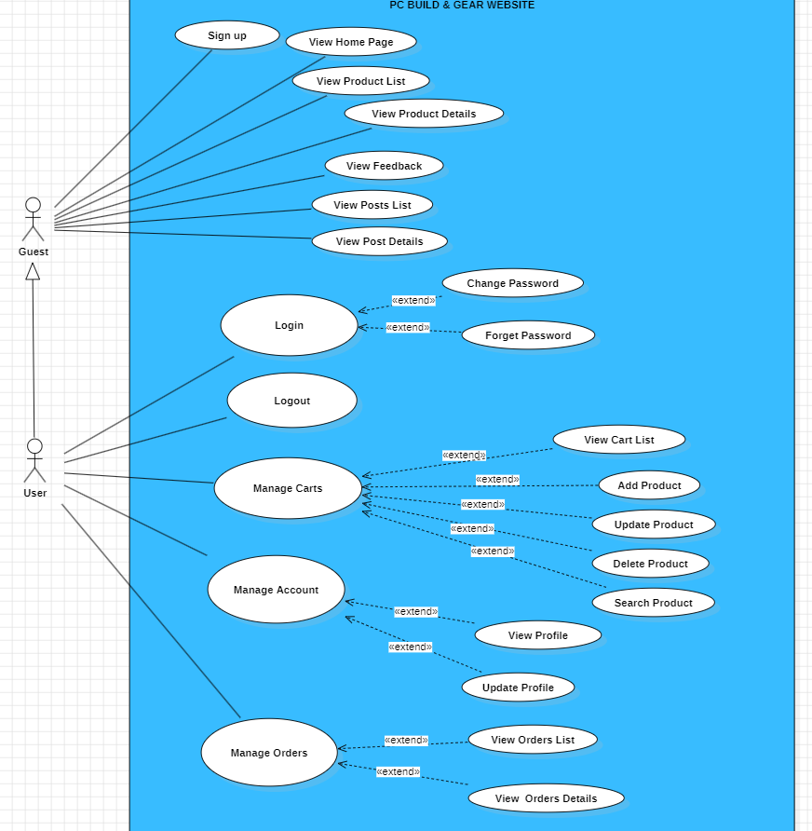

* Marketing:

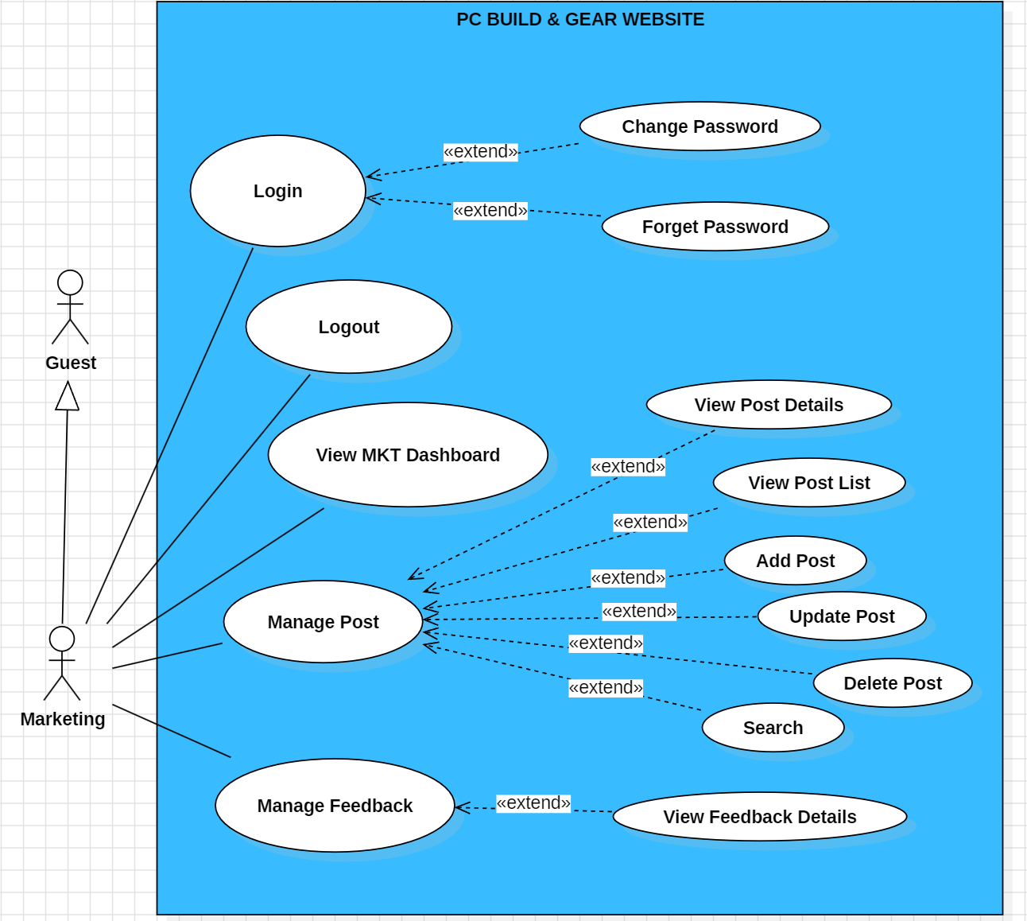

* Manager: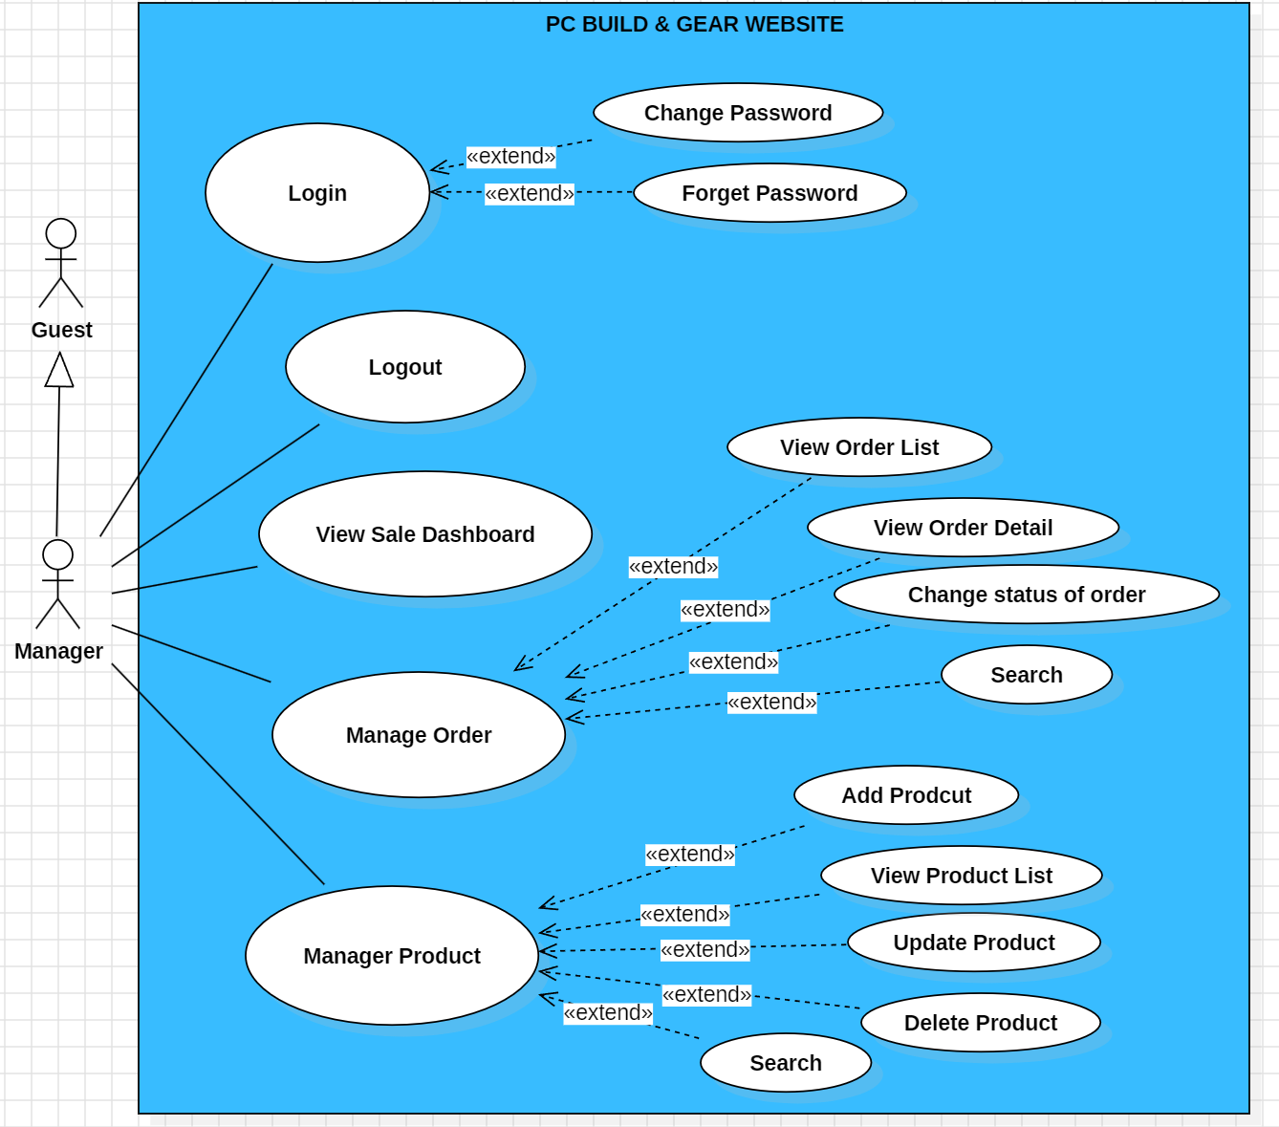
* Admin:

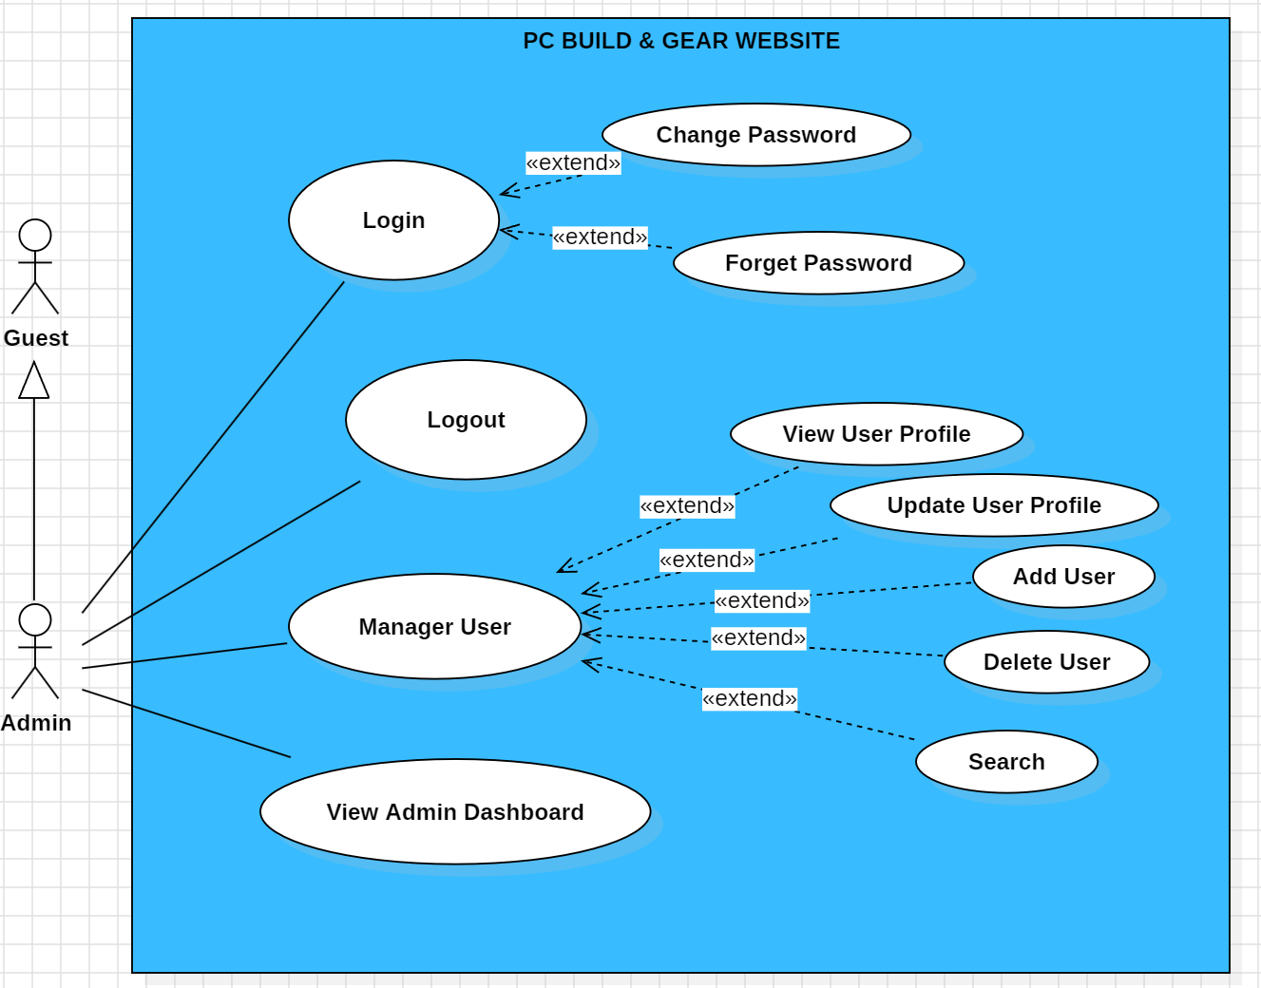

#### b. Descriptions

| **ID** | **Actor** | **Feature** | **Use Case** | **Use Case Description** | **Name** |
| --- | --- | --- | --- | --- | --- |
| 01 | Common | Login System | Login | User can log into the system by username and password | Mạnh Phú |
| 02 | Logout | User can logout from the system | Mạnh Phú |
| 03 | Sign up | Register a new account | Mạnh Phú |
| 04 | Change Password | User enters old password to change | Mạnh Phú |
| 05 | Landing Page | View Landing Page | - Show contact information with social links of the company.    - Show product information including its thumbnail, price | Hiếu |
| 06 | Manage Post | View Post list | - Show the newest posts list such as discount, new product, events | Hiếu |
| 07 | View Post Details | - Show the exact information about the post after choosing to view it | Hiếu |
| 07 |  | Search | * Search for product on page | Đạt |
| 08 | User | Manage Profile | View Profile | User can view their own profile | Mạnh Phú |
| 09 | Update User Profile | Update the information of the profile such as password, phone number | Mạnh Phú |
| 10 | View products | View products list | Allow user to view the list of products | Hiếu |
| 11 | View Products Detail | - Show product details (including title, category, images, original price, sale price, and product details) + the sider with the product search box, product categories, the latest products, and static contacts/links | Hiếu |
| 12 | Manage Order | View Order List | - Show the list of previous Order | Đạt |
| 13 | User/Manager | Manage Order | View Order Detail | - Show the order details, including the information as below + the sider with the product search box, product categories, the latest products, and static contacts/links    - The order id, order date, total cost, status    - The receiver information: full name, gender, email, mobile    - This list of ordered products, each product include following information & the links/buttons that allow the user to re-buy or feedback: thumbnail, name, category, unit price, quantity, total cost    - For the submitted orders, the user can choose to update (redirect the user to the Cart Details page for that) or cancel the order | Đạt |
| 15 | User | Manager Carts | View Cart List | - Show the list of products have added into the cart    - The user can change the quantity of each product: the total cost is automatically adjusted    - The user can choose to delete/remove product by clicking on the deleting icon    - The user can click the Choose More Product button to go to Products List page    - The user can click the Check Out button to go to the Cart Contact page | Mạnh phú |
| 16 | Add Product | - Add new products into the cart list | Mạnh Phú |
| 17 | Update Product | - Update details of products in the cart list such as number, color of products | Mạnh Phú |
| 18 | Search Product | - Search for any product that is in the cart list | Đạt |
| 19 | Delete product | - Remove products from the cart list | Đạt |
| 20 |  | Manage Order | Search | -Search for previous orders | Đạt |
| 21 | Marketing | Manage Post | View MKT Dashboard | - Show statistics of posts, products, customers, feedbacks & the trend of new customers | Hiếu |
| 22 | View Post Details | - Show detailed post information (thumbnail, category, title, brief information, description, flag to turn the featurning on/off, status), from that allow the user to input, view or edit them | Hiếu |
| 23 | Add Post | - Create a new post and post onto the system | Hiếu |
| 24 | Update Post | - Change the detail of the post such as content, image | Hiếu |
| 25 | Delete Post |  | Hiếu |
| 26 | Search Post |  | Hiếu |
| 27 | Manager | Manage Order | View Manager Dashboard | - Show the trend of success/total orders, and the revenues trends (the start date, end date, sale, order status can be adjustable) | Đạt |
| 28 | View Order List | -View list of all order in the system | Đạt |
| 29 | Change status of order | - Update the status of the order such as accepted or not accepted | Đạt |
| 30 | Search | - Can search for every Order in the system | Đạt |
| 31 | Manage Product | Add Product | - Create a new product to put on the web | Minh |
| 32 | View Product List | - Show the list of products that are being sold | Minh |
| 33 | Update Product | - Change the information of the product such as name, number, price | Minh |
| 34 | Delete product | - Remove the product from the Product List | Minh |
| 35 | Admin | Manage User | View Admin Dashboard | - Show list of all User | Minh |
| 36 | View User Profile | - Show detailed user information (avatar, full name, gender, email, mobile, role, address, status), from that allow the user to add new, view or edit user information | Minh |
| 37 | Update User Profile | - The admin can only edit/update the role and status of the user | Minh |
| 38 | Add User | - Add new user into the system | Minh |
| 39 | Delete User | - Remove user from the system | Minh |
| 40 | Search User | - Search for the user in the system | Minh |

## 

## 2. Overall Functionalities

### 2.1 Screens Flow

### z2.1a: Screens flow of public application for normal user, guest

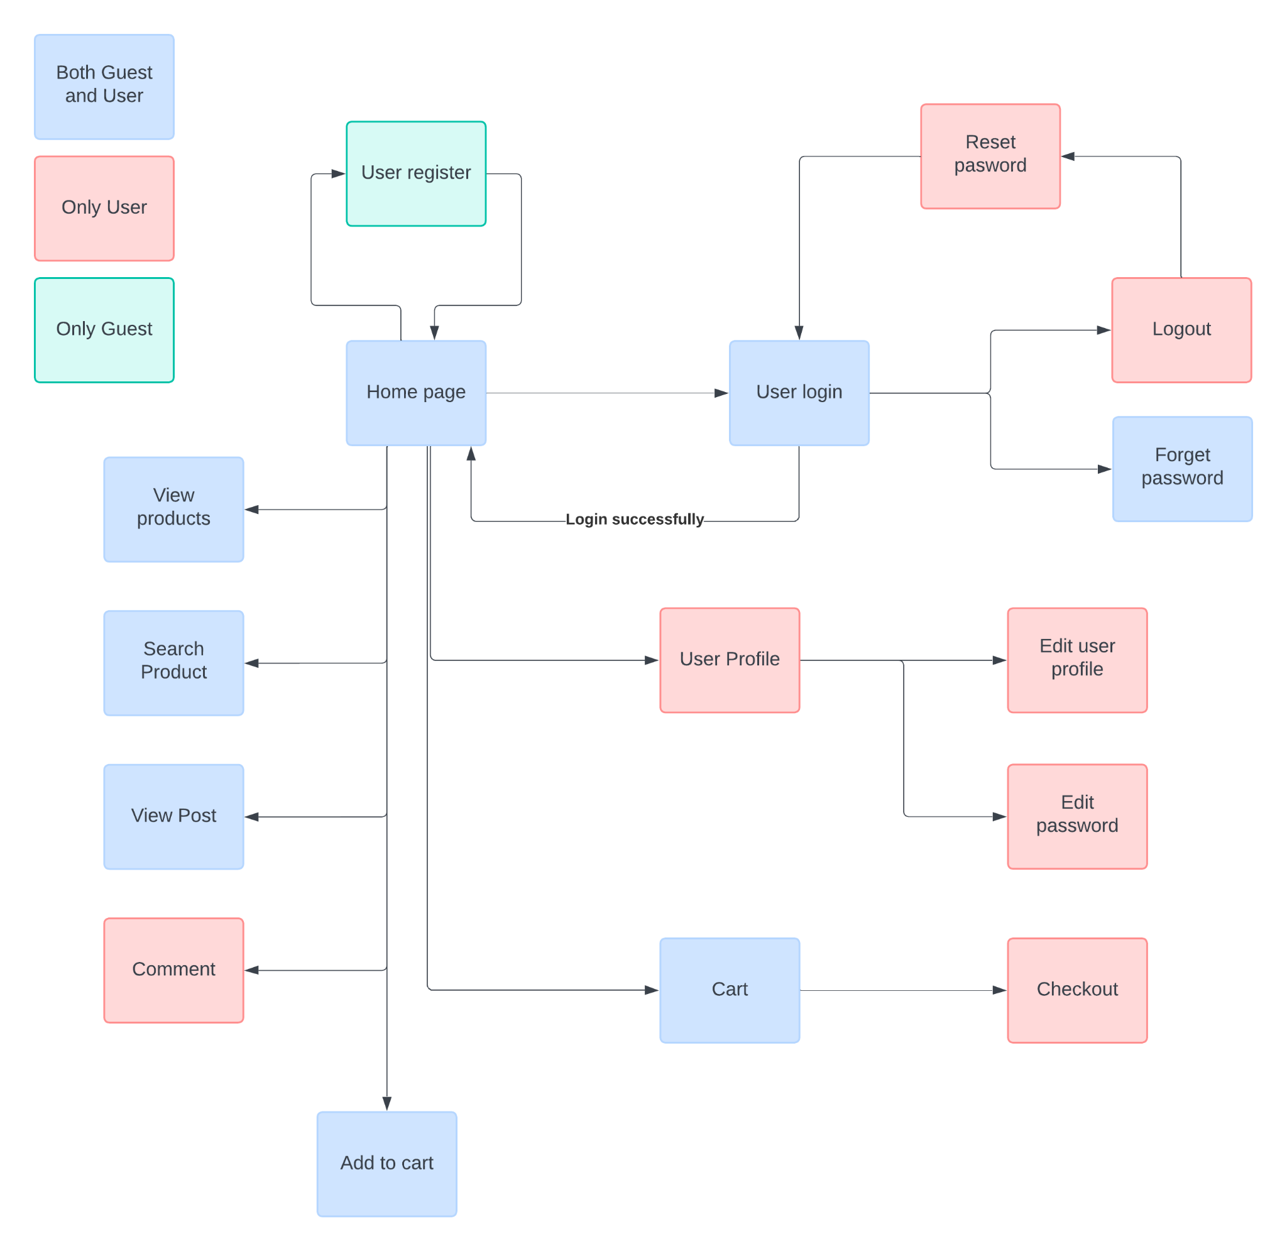

### 2.1b: Screens flow of public application for system’s administration

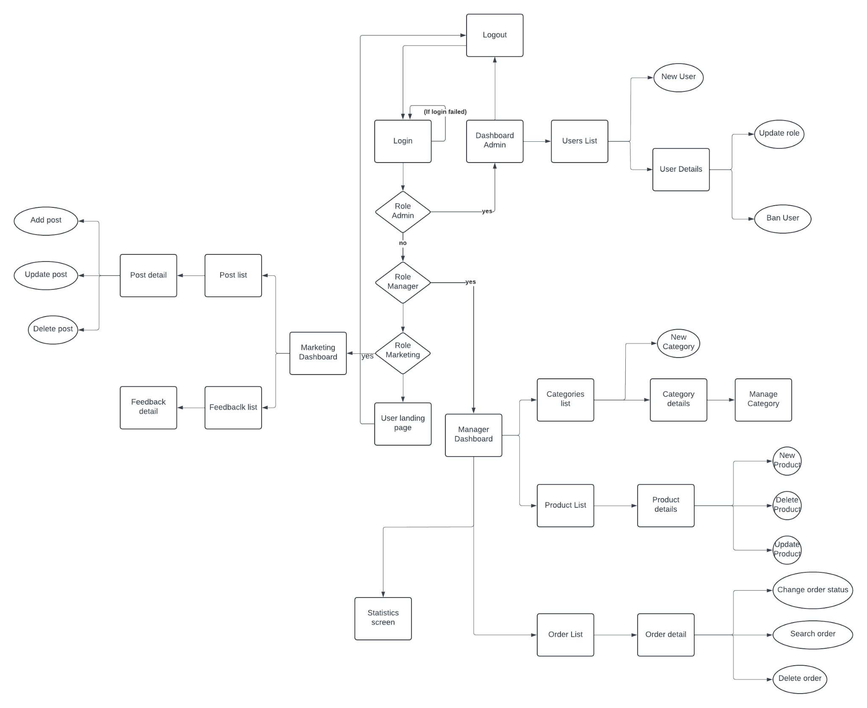

### 2.2 Screen Descriptions

| **#** | **Feature** | **Screen** | **Description** |
| --- | --- | --- | --- |
| 1 | View Home Page | Home Page | View Landing Page |
| 2 | Create an account | User Register | Register a new account |
| 3 | Login into the system | User Login | Login by email & password |
| 4 | Forget password | Forget Password | Allows the user to change password |
| 5 | Log out from the system | Log out | Exit the account |
| 6 | Change password | Reset Password | Allows the user to reset password |
| 7 | View user profile | User Profile | View user profile information |
| 8 | Update user profile | Edit Profile | Update information for user into the system |
| 9 | Update password | EditPassword | Allows the user to change password |
| 11 | Checkout | Checkout | Allow user to pay for goods |
| 12 | View products | View products | Allow user to view the list of products |
| 13 | Search products | Search products | Allow user to search for the products they want to find |
| 14 | View post | View post | Allow user to view the post in the system |
| 15 | Comment the post | Comment | Users can send their comments into posts |
| 16 | View Marketing Dashboard | Marketing Dashboard | Allow the marketing users to view the dashboard for marketing |
| 17 | View post list | Post list | Allow users to view the list of posts, detail of posts |
| 18 | Edit the post | Post detail | Allow users to update or delete the posts |
| 19 | View feedback list | Feedback | Allow users to view the list of feedbacks and details |
| 20 | View Manager Dashboard | Manager Dashboard | Allow users to view the Dashboard for manager |
| 21 | View category list | Category list | View the list of category, details |
| 22 | Add new category | Category list | Allow users to add new category into the system |
| 23 | View product list | Product list | Allow users to view the list of products and products details |
| 24 | Edit the product | Product details | Allow uses to add new products, update information and delete products |
| 25 | View order list | Order list | View the list of order and detail onto the screen |
| 26 | Edit order | Order detail | User can change the status of order, search for order or delete order |
| 27 | View Admin Dashboard | Admin Dashboard | Allow users to view the dashboard for admin |
| 28 | View User List | User List | View the list of users of the system and details of users |
| 29 | Add new user | Admin Dashboard | Add new users into the system |
| 30 | Edit Users detail | Users details | Update the role or ban users |
| 31 |  |  |  |
| 32 |  |  |  |
| 33 |  |  |  |
| 34 |  |  |  |
| 35 |  |  |  |

### 2.3 Screen Authorization

| **Screen** | **Guest** | **User** | **Marketing** | **Manager** | **Admin** |
| --- | --- | --- | --- | --- | --- |
| Landing Page | X | x |  |  |  |
| User Register | x | x |  |  |  |
| User Login | X | x | X |  | x |
| Log out | X | x | x |  | x |
| Forgot Password | x | x | X |  | x |
| Reset Password | x | x | X |  | x |
| User Profile |  | x | X | X | x |
| Edit Profile |  | x | x | X | x |
| Change Password |  | x | x | X | x |
|  |  |  |  | X |  |
|  |  |  |  |  |  |
|  |  |  |  |  |  |

### 2.4 Non-UI Functions

| **#** | **Feature** | **System Function** | **Description** |
| --- | --- | --- | --- |
| 1 | <<Feature Name>> | <<Function Name1>> | <<Function Name1 Description>> |
| 2 | … |  |  |

## 3. System High Level Design

### 3.1 Database Design

#### a. Database Schema

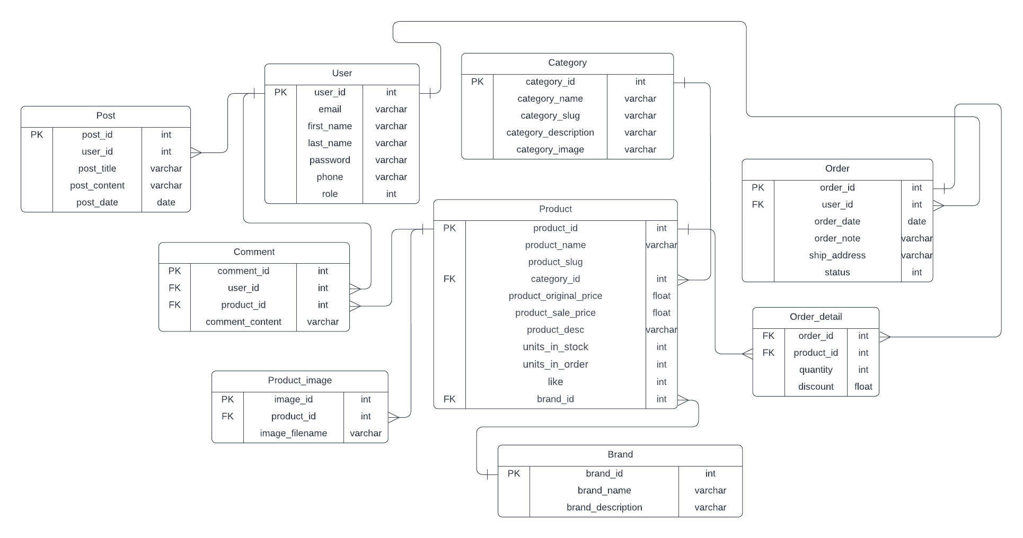

#### b. Table Descriptions

### 

| **No** | **Table** | **Description** |
| --- | --- | --- |
| 01 | User | Contains information about the users of the application, such as user ID, username, password, email, and other personal details. |
| 02 | Product | Stores details about products, such as product ID, name, description, price, stock quantity, category ID, and brand ID. |
| 03 | Order | Represents customer orders, containing order ID, user ID, order date, total amount, and order status |
| 04 | Order_detail | Details of each order, including order ID, product ID, quantity. |
| 05 | Post | Stores posts, such as blog posts or news articles, including post ID, title, content, user ID, and publication date. |
| 06 | Category | Stores categories for products, including category ID, name, image and description. |
| 07 | Brand | Contains information about product brands, including brand ID, name, and description. |
| 08 | Product_image | Stores images for products, including product image ID, product ID and image file name. |
| 09 | Comment | Contains user comments or reviews for products, including comment ID, user ID, product ID, content |

# 

**1.Table Users**

| **Field Name** | **Data Type** | **Field Size** | **Format** | **Caption** | **Description** |
| --- | --- | --- | --- | --- | --- |
| user_id | int |  |  |  | Primary key, Identity |
| email | varchar | 45 |  |  | UNIQUE |
| first_name | varchar | 45 |  |  | Not null |
| last_name | varchar | 45 |  |  |  |
| password | varchar | 45 |  |  | Not null |
| phone | varchar | 15 |  |  |  |
| role | int |  |  |  | Not null |

**2.Table Products**

| **Field Name** | **Data Type** | **Field Size** | **Format** | **Caption** | **Description** |
| --- | --- | --- | --- | --- | --- |
| product_id | int |  |  |  | Primary key, Identity |
| product_name | varchar | 100 |  |  |  |
| product_slug | varchar | 250 |  |  |  |
| category_id | int |  |  |  |  |
| product_original_price | float |  |  |  | Not null |
| product_sale_price | float |  |  |  |  |
| product_desc | varchar |  |  |  |  |
| units_in_stock | int |  |  |  |  |
| units_on_order | int |  |  |  |  |
| like | int |  |  |  |  |
| brand_id | int |  |  |  | Foreign key |

**3.Table Order**

| **Field Name** | **Data Type** | **Field Size** | **Format** | **Caption** | **Description** |
| --- | --- | --- | --- | --- | --- |
| order_id | int |  |  |  | Primary key,  Identity |
| order_date | date |  |  |  |  |
| order_note | varchar | 250 |  |  |  |
| ship_address | varchar | 100 |  |  |  |
| status | int |  |  |  | Not null |

### **4. Table Order_detail**

| **Field Name** | **Data Type** | **Field Size** | **Format** | **Caption** | **Description** |
| --- | --- | --- | --- | --- | --- |
| order_id | int |  |  |  | Primary key, Identity |
| user_id | int |  |  |  | Foreign key referencing [User] table |
| order_date | date |  |  |  | Not null |
| order_note | varchar | 250 |  |  |  |
| ship_address | varchar | 250 |  |  | Not null |
| status | int |  |  |  | Not null |

### **5.Table: Posts**

| **Field Name** | **Data Type** | **Field Size** | **Format** | **Caption** | **Description** |
| --- | --- | --- | --- | --- | --- |
| post_id | int |  |  |  | Primary key, Identity |
| user_id | int |  |  |  | Foreign key referencing [User] table |
| post_title | varchar | 100 |  |  | Not null |
| post_content | varchar | 260 |  |  | Not null |
| post_date | date |  |  |  | Not null |

### **6.Table: Category**

| **Field Name** | **Data Type** | **Field Size** | **Format** | **Caption** | **Description** |
| --- | --- | --- | --- | --- | --- |
| category_id | int |  |  | Primary key, Identity |  |
| category_name | varchar | 250 |  | Not null |  |
| category_description | varchar | 250 |  |  |  |
| category_image | varchar |  |  |  |  |

**7.Table Brand**

| **Field Name** | **Data Type** | **Field Size** | **Format** | **Caption** | **Description** |
| --- | --- | --- | --- | --- | --- |
| brand_id | int |  |  |  | Primary key,  Identity |
| brand_name | float |  |  |  | Not null |
| brand_description | varchar | 250 |  |  |  |

**8.Table Product_image**

| **Field Name** | **Data Type** | **Field Size** | **Format** | **Caption** | **Description** |
| --- | --- | --- | --- | --- | --- |
| image_id | int |  |  |  | Primary key,  Identity |
| product_id | int |  |  |  | Not null |
| image_filename | varchar | 250 |  |  |  |

**9.Table Comment**

| **Field Name** | **Data Type** | **Field Size** | **Format** | **Caption** | **Description** |
| --- | --- | --- | --- | --- | --- |
| comment_id | int |  |  |  | Primary key,  Identity |
| user_id | int |  |  |  | Not null |
| product_id | int |  |  |  | Not null |
| comment_contnet | varchar | 1000 |  |  |  |

#### 3.2 Code Packages

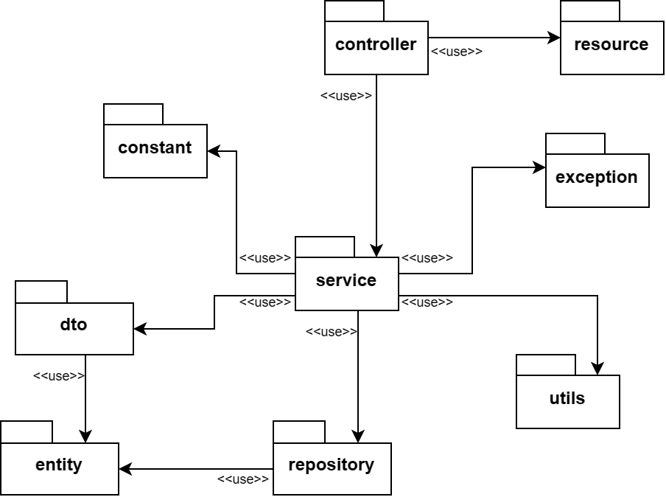

***Package descriptions***

| **No** | **Package** | **Description** |
| --- | --- | --- |
| 01 | controller | Handle the user requests, return responses and control the flow of the application |
| 02 | resource | Contains all files used for view (public assets, HTML, CSS, …) |
| 03 | constant | The constants used for the application |
| 04 | exception | Define custom exceptions and handle exceptions |
| 05 | service | Business logic, data handling, connect *repository* with *controller* |
| 06 | repository | Data Access Layer package, used to connect and access to databases |
| 07 | entity | Data Access Object package, used to map Java Objects with tables in databases |
| 08 | dto | Data Transfer Object package, used to simplify *entity* and to communicate in upper layer of the application |
| 09 | utils | Utility package, contains utility files |

# II. Requirement Specifications

## 1. <<Feature Name>>

### 1.1 <<UseCaseCode_UC Name>>

#### a. Functionalities

Provide the functional description for the use cases using the template/guides below

**Functional Description Template**

| UC ID and Name: |  | | |
| --- | --- | --- | --- |
| Created By: |  | Date Created: |  |
| Primary Actor: |  | Secondary Actors: |  |
| Trigger: |  | | |
| Description: |  | | |
| Preconditions: |  | | |
| Postconditions: |  | | |
| Normal Flow: |  | | |
| Alternative Flows: |  | | |
| Exceptions: |  | | |
| Priority: | High (Medium, Low), Must Have (Should Have, Could Have),.. | | |
| Frequency of Use: |  | | |
| Business Rules: |  | | |
| Other Information: |  | | |
| Assumptions: |  | | |

**Functional Description Contents**

***Use Case ID and Name***

Give each use case a unique integer sequence number identifier. State a concise name for the use case that indicates the value the use case would provide to some user. Begin with an action verb, followed by an object.

***Author and Date Created***

Enter the name of the person who initially wrote this use case and the date it was written.

***Primary and Secondary Actors***

An actor is a person or other entity external to the software system being specified who interacts with the system and performs use cases to accomplish tasks. Different actors often correspond to different user classes, or roles, identified from the customer community that will use the product. Name the primary actor that will be initiating this use case and any other secondary actors who will participate in completing execution of the use case.

***Trigger***

Identify the business event, system event, or user action that initiates the use case. This trigger alerts the system that it should begin testing the preconditions for the use case so it can judge whether to proceed with execution.

***Description***

Provide a brief description of the reason for and outcome of this use case, or a high-level description of the sequence of actions and the outcome of executing the use case.

***Preconditions***

List any activities that must take place, or any conditions that must be true, before the use case can be started. The system must be able to test each precondition. Number each precondition. Example: PRE-1: User’s identity has been authenticated.

***Postconditions***

Describe the state of the system at the successful conclusion of the use case execution. Label each postcondition in the form POST-X, where X is a sequence number. Example: POST-1: Price of item in the database has been updated with the new value.

***Normal Flow***

Provide a description of the user actions and corresponding system responses that will take place during execution of the use case under normal, expected conditions. This dialog sequence will ultimately lead to accomplishing the goal stated in the use case name and description. Show a numbered list of actions performed by the actor, alternating with responses provided by the system. The normal flow is numbered “X.0”, where “X” is the Use Case ID.

***Alternative Flows***

Document other successful usage scenarios that can take place within this use case. State the alternative flow, and describe any differences in the sequence of steps that take place. Number each alternative flow in the form “X.Y”, where “X” is the Use Case ID and Y is a sequence number for the alternative flow. For example, “5.3” would indicate the third alternative flow for use case number 5. Indicate where each alternative flow would branch off from the normal flow, and if pertinent, where it would rejoin the normal flow.

***Exceptions***

Describe any anticipated error conditions that could occur during execution of the use case and how the system is to respond to those conditions. Number each alternative flow in the form “X.Y.EZ”, where “X” is the Use Case ID, Y indicates the normal (0) or alternative (>0) flow during which this exception could take place, “E” indicates an exception, and “Z” is a sequence number for the exceptions. For example “5.0.E2” would indicate the second exception for the normal flow for use case number 5. Indicate where in the normal (or an alternative) flow each exception could occur.

***Priority***

Indicate the relative priority of implementing the functionality required to allow this use case to be executed. Use the same priority scheme as that used for the functional requirements.

***Frequency of Use***

Estimate the number of times this use case will be performed per some appropriate unit of time. This gives an early indicator of throughput, concurrent usage loads, and transaction capacity.

***Business Rules***

List any business rules that influence this use case. Don’t include the business rule text here, just its identifier so the reader can find it in another repository when needed.

***Other Information***

Identify any additional requirements, such as quality attributes, for the use case that may need to be addressed during design or implementation. Also list any associated functional requirements that aren’t a direct part of the use case flows but which a developer needs to know about. Describe what should happen if the use case execution fails for some unanticipated or systemic reason (e.g., loss of network connectivity, timeout). If the use case results in a durable state change in a database or the outside world, state whether the change is rolled back, completed correctly, partially completed with a known state, or left in an undetermined state as a result of the exception.

***Assumptions***

List any assumptions that were made regarding this use case or how it might execute.

#### b. Business Rules

Provide the business rules those are applied only to the use case

| **ID** | **Business Rule** | **Business Rule Description** |
| --- | --- | --- |
| FR1 | Password Encoding | User’s password must be encoded with MD5 hashing |

## 2. Common Functions

### 2.1 UC-2_Login System

#### a. Functional Description

| UC ID and Name: | **UC-2_Login System** | | |
| --- | --- | --- | --- |
| Created By: | MinhNNT | Date Created: | 16/Jun/2023 |
| Primary Actor: | Customer | Secondary Actors: | None |
| Trigger: | User clicks Login button from the page header, or  User accesses an authenticated feature (from a link or type the page URL directly into the address bar) | | |
| Description: | As a user, I want to be able to log into the system so that I can use the system’s authenticated features and access my personalized account. | | |
| Preconditions: | User account has been created & authorized | | |
| Postconditions: | * User logs in the system successfully * The system tracked successful login into the Activity Log | | |
| Normal Flow | **2.0 Login System**  1. User accesses the User Login screen  2. User types in the login details or choo other login options (see 2.1 and 2.2)  3. User clicks the Login button  4. System validates the login details (see 2.0.E1)  5. System allows user to access  6. System tracks user’s success login to the Activity Log  7. System accesses the Home Page (or the previous calling page if any) | | |
| Alternative Flows: | ***2.1 Google Login***  1. User chooses to login system using Google account  2. System redirects the user to the Google’s Login screen  3. User types in the Google account details and chooses to login  4. Google validates user’s login information successfully and redirect him/her back to the system  5. Return to step 5 of normal flow.  ***2.2 Facebook Login***  1. User chooses to login system using Facebook account  2. System redirects the user to the Facebook’s Login screen  3. User types in the Facebook account details and chooses to login  4. Facebook validates user’s login information successfully and redirect him/her back to the system  5. Return to step 5 of normal flow. | | |
| Exceptions: | ***2.0.E1 System can’t authenticate the user***  1. The Error Message screen is shown to the user  2. User cancels the logging in *=> UC stops, change to UC-1_View Home Page*  3. User clicks “Forgot Password?” link *=> change to UC-3_Reset Password*  4. User clicks “Register” link *=> change to UC-4_Register User Account* | | |
| Priority: | Must Have | | |
| Frequency of Use: |  | | |
| Business Rules: | FR1, FR2, FR3 | | |
| Other Information: |  | | |
| Assumptions: |  | | |

#### b. Business Rules

| **ID** | **Business Rule** | **Business Rule Description** |
| --- | --- | --- |
| FR1 | Password Encoding | User’s password must be encoded with MD5 hashing |
| FR2 | Invalid Logging In | User can’t be authenticated to login the system if below cases   * His/her logging-in details are incorrect * His/her account has not been verified * His/her account has been locked or blocked |
| FR3 | Account Locking | If user inputs wrong logging-in details 6 times continuously, his/her account would be locked in 30 minutes |

## 3. Patron Feature

### 3.1 UC-5_Order a Meal

#### a. Functional Description

| ID and Name: | **UC-5 Order a Meal** | | |
| --- | --- | --- | --- |
| Created By: | Prithvi Raj | Date Created: | 10/4/13 |
| Primary Actor: | Patron | Secondary Actors: | Cafeteria Inventory System |
| Description: | A Patron accesses the Cafeteria Ordering System from the corporate intranet or from home, views the menu for a specific date if desired, selects food items, and places an order for a meal to be delivered to a specified location within a specified 15-minute time window. | | |
| Trigger: | A Patron indicates that he wants to order a meal | | |
| Preconditions: | PRE-1. Patron is logged into COS.  PRE-2. Patron is registered for meal payments by payroll deduction. | | |
| Postconditions: | POST-1. Meal order is stored in COS with a status of “Accepted”.  POST-2. Inventory of available food items is updated to reflect items in this order.  POST-3. Remaining delivery capacity for the requested time window is updated. | | |
| Normal Flow: | **5.0 Order a Single Meal**   1. Patron asks to view menu for a specific date. (see 5.0.E1, 5.0.E2) 2. COS displays menu of available food items and the daily special. 3. Patron selects one or more food items from menu. (see 5.1) 4. Patron indicates that meal order is complete. (see 5.2) 5. COS displays ordered menu items, individual prices, and total price, including taxes and delivery charge. 6. Patron either confirms meal order (continue normal flow) or requests to modify meal order (return to step 2). 7. COS displays available delivery times for the delivery date. 8. Patron selects a delivery time and specifies the delivery location. 9. Patron specifies payment method. 10. COS confirms acceptance of the order. 11. COS sends Patron an email message confirming order details, price, and delivery instructions. 12. COS stores order, sends food item information to Cafeteria Inventory System, and updates available delivery times. | | |
| Alternative Flows: | **5.1 Order multiple identical meals**   1. Patron requests a specified number of identical meals. (see 5.1.E1) 2. Return to step 4 of normal flow.   **5.2 Order multiple meals**   1. Patron asks to order another meal. 2. Return to step 1 of normal flow. | | |
| Exceptions: | **5.0.E1 Requested date is today and current time is after today’s order cutoff time**  1. COS informs Patron that it’s too late to place an order for today.  2a. If Patron cancels the meal ordering process, then COS terminates use case.  2b. Else if Patron requests another date, then COS restarts use case.  **5.0.E2 No delivery times left**  1. COS informs Patron that no delivery times are available for the meal date.  2a. If Patron cancels the meal ordering process, then COS terminates use case.  2b. Else if Patron requests to pick the order up at the cafeteria, then continue with normal flow, but skip steps 7 and 8.  **5.1.E1 Insufficient inventory to fulfill multiple meal order**  1. COS informs Patron of the maximum number of identical meals he can order, based on current available inventory.  2a. If Patron modifies number of meals ordered, then Return to step 4 of normal flow.  2b. Else if Patron cancels the meal ordering process, then COS terminates use case. | | |
| Priority: | High | | |
| Frequency of Use: | Approximately 300 users, average of one usage per day. Peak usage load for this use case is between 9:00 A.M. and 10:00 A.M. local time. | | |
| Business Rules: | BR-1, BR-2, BR-3, BR-4, BR-11, BR-12, BR-33 | | |
| Other Information: | 1. Patron shall be able to cancel the meal ordering process at any time prior to confirming it. 2. Patron shall be able to view all meals he ordered within the previous six months and repeat one of those meals as the new order, provided that all food items are available on the menu for the requested delivery date. (Priority = M) 3. The default date is the current date if the Patron is using the system before today’s order cutoff time. Otherwise, the default date is the next day that the cafeteria is open. | | |
| Assumptions: | Assume that 15 percent of Patrons will order the daily special (source: previous 6 months of cafeteria data). | | |

#### b. Business Rules

None

### 3.2 UC-6_Register for Payroll Deduction

#### a. Functional Description

| ID and Name: | **UC-6 Register for Payroll Deduction** | | |
| --- | --- | --- | --- |
| Created By: | Nancy Anderson | Date Created: | 9/15/13 |
| Primary Actor: | Patron | Secondary Actors: | Payroll System |
| Description: | Cafeteria patrons who use the COS and have meals delivered must be registered for payroll deduction. For noncash purchases made through the COS, the cafeteria will issue a payment request to the Payroll System, which will deduct the meal costs from the next scheduled employee payday direct deposit. | | |
| Trigger: | Patron requests to register for payroll deduction, or Patron says yes when COS asks if he wants to register | | |
| Preconditions: | PRE-1. Patron is logged into COS. | | |
| Postconditions: | POST-2. Patron is registered for payroll deduction. | | |
| Normal Flow: | **6.0 Register for Payroll Deduction**   1. COS asks Payroll System if Patron is eligible to register for payroll deduction. 2. Payroll System confirms that Patron is eligible to register for payroll deduction. 3. COS asks Patron to confirm his desire to register for payroll deduction. 4. If so, COS asks Payroll System to establish payroll deduction for Patron. 5. Payroll System confirms that payroll deduction is established. 6. COS informs Patron that payroll deduction is established. | | |
| Alternative Flows: | None | | |
| Exceptions: | 6.0.E1 Patron is not eligible for payroll deduction  6.0.E2 Patron is already enrolled for payroll deduction | | |
| Priority: | High | | |
| Business Rules: | BR-86 and BR-88 govern an employee’s eligibility to enroll for payroll deduction. | | |
| Other Information: | Expect high frequency of executing this use case within first 2 weeks after system is released. | | |

#### b. Business Rules

None

# III. Design Specifications

## 1. <<Feature Name>>

### 1.1 <<SubFeature Name>>

#### a. <<Screen/Function Name>>

*[Provide brief description of the screen/function + related UC here and other details as in the sub-sections]*

##### UI Design

*[This is to describe the UI layout (Mockup prototype) & descriptions for screen fields/components]*

<<Mockup prototype>>

| **Field Name** | **Field Type** | **Description** |
| --- | --- | --- |
| ***Field Group Name*** | | |
| <<Field-Name>> | <<Field type>> | <<Field description & data initializing design>> |

##### Database Access

*[Provide the design description for the screen/function to access the database here: what table the screen/function would access, which transactions does it make (C-Create, R-Read, U-Update, or D-Delete), and how/purpose of the access (by providing Description and SQL commands)]*

| **Table** | **CRUD** | **Description** |
| --- | --- | --- |
| <<Table Name>> | <<transaction(s)>> | <<Table access description: purpose, how,…>> |
| .. |  |  |

***SQL Commands***

*[Provide the detailed SQL (select, insert, update...) which are used in implementing the screen/function]*

### 1.2 System Access

#### a. User Login

This screen allows user to be authenticated to the system screens/functionalities.

Related use cases:

* UC02_Login System

##### UI Design

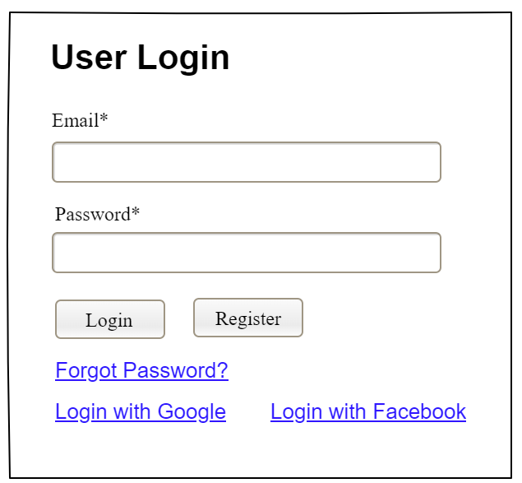

| **Field Name** | **Field Type** | **Description** |
| --- | --- | --- |
| Email* | Text Box | This is for user to input valid email address for logging in |
| Password* | Password Box | This is for user to input password for logging in |
| Login | Button | User clicks to authenticate him/herself into the system with provided email & password |
| Register | Button | User clicks to redirect to the User Register page for registering new user account to access the system |
| Forgot Password? | Hyperlink | User clicks to redirect to the Password Reset page for resetting his/her forgot password |
| Login with Google | Hyperlink | Allow user to login with his/her Google account |
| Login with Facebook | Hyperlink | Allow user to login with his/her Facebook account |

##### Database Access

| **Table** | **CRUD** | **Description** |
| --- | --- | --- |
| User | R | Verify UserName & Password information |
| Setting, User | R | Specify the authorizations of the logged-in user |

***SQL Commands:***

1/ Verify UserName & Password information

SELECT user_id, full_name, email, image_url, status

FROM user WHERE user_name = ? AND password = ?

2/ Specify the authorizations of the logged-in user

SELECT mapped_values FROM setting WHERE setting_id = ?

SELECT setting_name, mapped_values FROM setting WHERE setting_id IN (?)

#### b. Setting List

##### UI Design

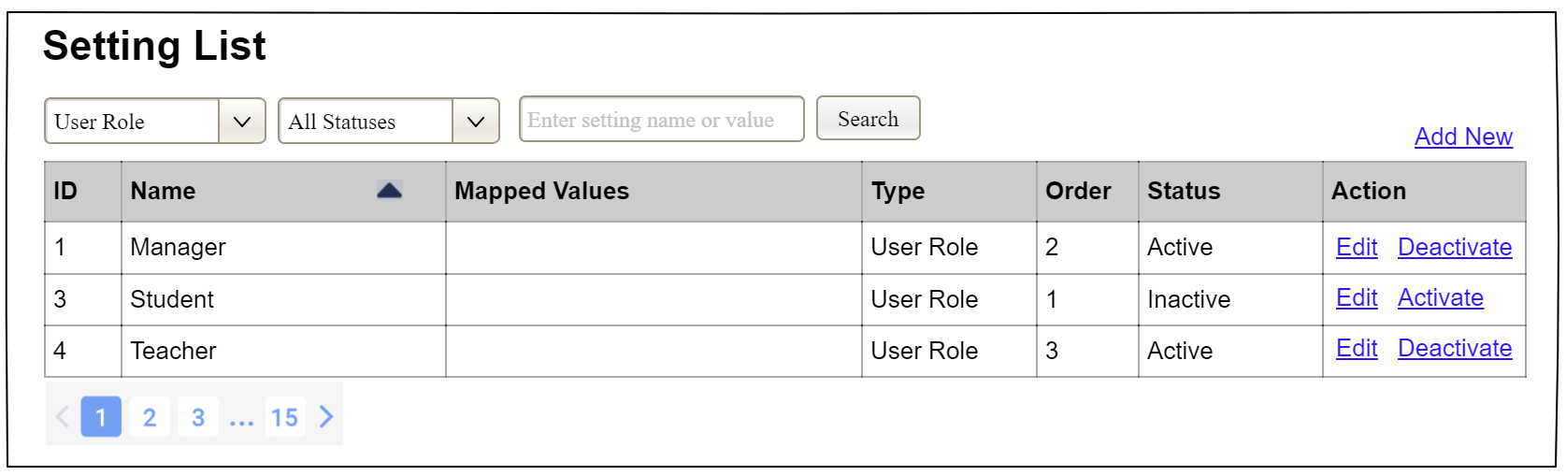

| **Field Name** | **Field Type** | **Description** |
| --- | --- | --- |
| ***Search Fields*** | | |
| Setting Type | Combo Box  Single-Choice | Filled with the list of current active setting types  Allow to filter the list by setting type;  Default value is “All Types” |
| Setting Status | Combo Box  Single-Choice | Values: All Statuses (default), Active, and Inactive  Allow to filter the list by status  Default value: “All Statuses” |
| Search Phase | Text Box  String (30) | Allow to search using the name or map values  Default value: blank |
| Search | Button | Click to refresh the list with the defined filter(s) and search phrase. |
| Add New | Hyperlink | Click to open the Setting Details page for adding new setting (master data) |
| ***Data Table*** | | |
| ID | Integer | Auto-increased identifier of the setting |
| Name | Text | Name of the setting |
| Mapped Values | Text | Supplementary information for the setting |
| Type | Text | Type of the setting |
| Order | Integer | Display order of the setting: the order of the setting type, displayed among the list of settings with the same type |
| ***Data Actions*** | | |
| Edit | icon | Click to open the Setting Details page for updating the relevant setting (master data) |
| Activate | icon | Shown when the data status is inactive. This is to activate the relevant setting (master data) |
| Deactivate | Ion | Shown when the data status is active. This is to deactivate the relevant setting (master data) |

##### Database Access

| **Table** | **CRUD** | **Description** |
| --- | --- | --- |
| Setting | RU | Query the list of current settings from the database  Update status of a specific setting |

***SQL Commands:***

1/ Query the list of current settings from the database

SELECT setting_id, setting_name, mapped_values, type_id, display_order, status

FROM setting WHERE (setting_type = ?) AND (status = ?) AND (setting_name LIKE ?)

2/ Update status of a specific setting

UPDATE setting SET status = ? WHERE setting_id = ?

#### c. Setting Details

##### UI Design

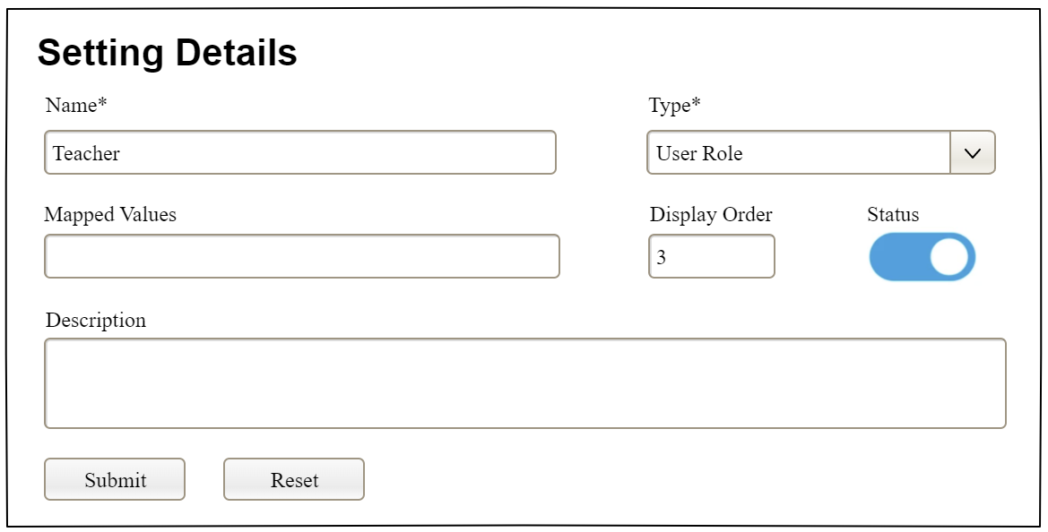

| **Field Name** | **Field Type** | **Description** |
| --- | --- | --- |
| Name* | Text Box  String (20) | Name of the setting |
| Type* | Combo Box  (Single Choice) | Type of the setting, filled with the list of setting types  Default value: the first type in the list |
| Mapped Values | Text Box  String (50) | Supplementary information for the setting (if any) |
| Order | Text Box  Integer (>=0) | Display order of the setting: the order of the setting type, displayed among the list of settings with the same type |
| Status | On/Off button | Status of the setting: Active or Inactive  Default value: Active |
| Description | Text Area  String (200) | Description of the setting |
| Submit | Button | Click to store new or updated setting details |
| Reset | Button | Click to reset the changes use has made on the screen fields back to the initial values when the screen is loaded |

##### Database Access

…

# IV. Appendix

## 1. Assumptions & Dependencies

*[Record any assumptions that were made when conceiving the project and writing this vision and scope document. Note any major dependencies the project must rely upon for success, such as specific technologies, third-party vendors, development partners, or other business relationships.]*

<<Sample:

AS-1: Systems with appropriate user interfaces will be available for cafeteria employees to process the expected volume of meals ordered.

AS-2: Cafeteria staff and vehicles will be available to deliver all meals for specified delivery time slots within 15 minutes of the requested delivery time.

DE-1: If a restaurant has its own on-line ordering system, the Cafeteria Ordering System must be able to communicate with it bi-directionally.

>>

## 2. Limitations & Exclusions

*[Identify any product features or characteristics that a stakeholder might anticipate, but which are not planned to be included in the new product]*

## 3. Business Rules

*[Provide common business rules that you must follow. The information can be provided in the table format as the sample below]*

<<Sample

| **ID** | **Category** | **Rule Definition** |
| --- | --- | --- |
| BR-01 | Constraints | Delivery time windows are 15 minutes, beginning on each quarter hour. |
| BR-02 | Constraints | Deliveries must be completed between 10:00 A.M. and 2:00 P.M. local time, inclusive. |
| BR-03 | Facts | All meals in a single order must be delivered to the same location. |
| BR-04 | Facts | All meals in a single order must be paid for by using the same payment method. |
| BR-11 | Constraints | If an order is to be delivered, the patron must pay by payroll deduction. |
| BR-12 | Computations | Order price is calculated as the sum of each food item price times the quantity of that food item ordered, plus applicable sales tax, plus a delivery charge if a meal is delivered outside the free delivery zone. |
|  |  |  |

>>

## 4. ..